**Experiment -1.1**

**Student Name:** Atinshay Awasthi **UID:** 22BDO10007

**Branch:** CSE-DevOps **Section/Group:** 22BCD-1/A

**Semester:** 4th **Date of Performance:**17-1-23

**Subject Name:** Git And Github **Subject Code:** 22CSH-293

**1. Aim/Overview of the practical:** Install Git and create the repository.

**2. Task to be done:** Download Git for Windows, Basic Configurations, to make repository.

**3. Apparatus:**

**4. Theme/Interests definition:** Git is a distributed version control system that helps track changes in source code during software development.

**6. Steps for experiment/practical:**  
1. Browse to the official Git website: <https://git-scm.com/downloads>.Click the download link for Windows and allow the download to complete.

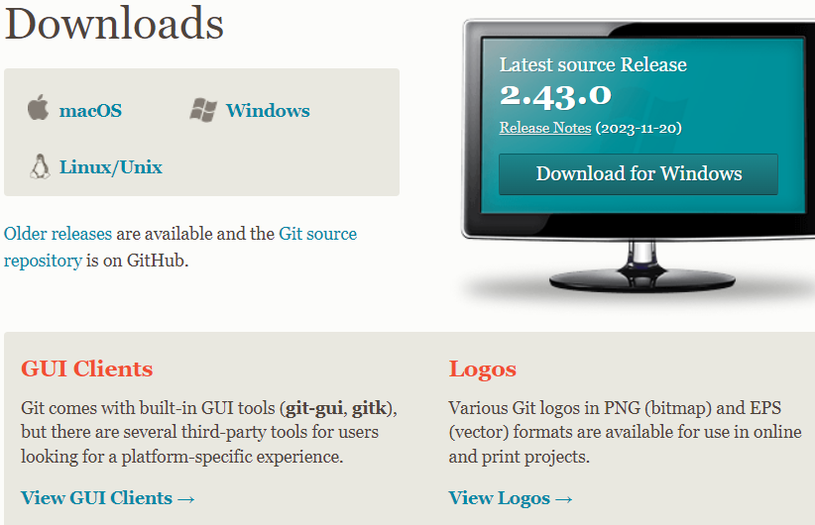

2. Allow the app to make changes to your device by clicking **Yes** on the User Account Control dialog that opens.

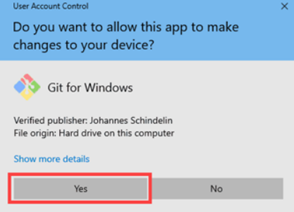

3. Review the [GNU General Public License](https://phoenixnap.com/glossary/gnu-general-public-license), and when you’re ready to install, click **Next**.

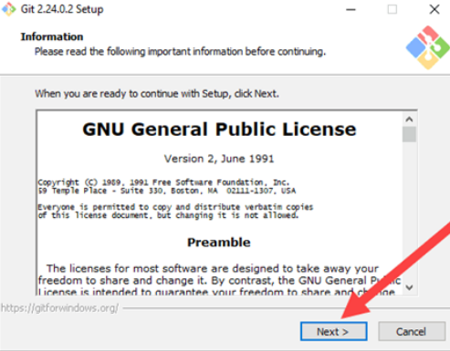

4. The installer will ask you for an installation location. Leave the default, unless you have reason to change it, and click **Next**.

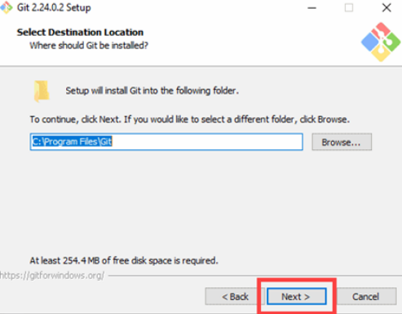

5. A component selection screen will appear. Leave the defaults unless you have a specific need to change them and click **Next**.

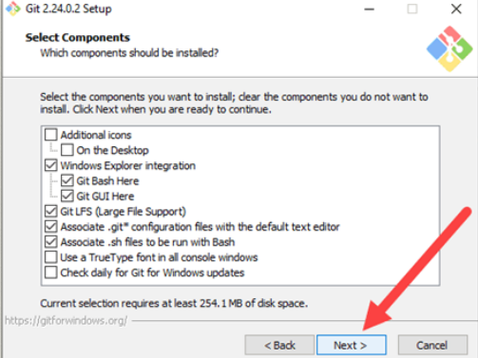

6. The installer will offer to create a start menu folder. Simply click **Next**.

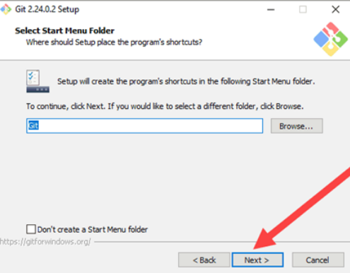

7. Select a text editor you’d like to use with Git. Use the drop-down menu to select Notepad++ (or whichever text editor you prefer) and click **Next**.

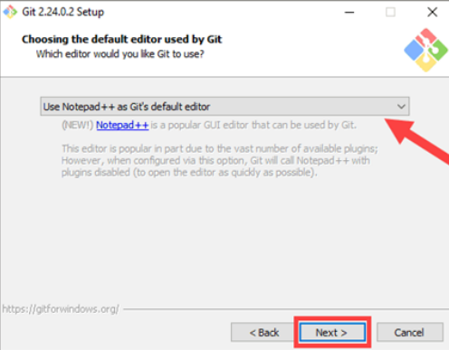

8. The next step allows you to choose a different name for your initial branch. The default is 'master.' Unless you're working in a team that requires a different name, leave the default option and click **Next.**

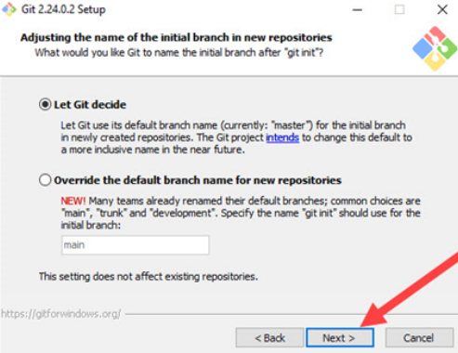

9. This installation step allows you to change the **PATH environment**. The **PATH**is the default set of directories included when you run a command from the command line. Leave this on the middle (recommended) selection and click **Next**.

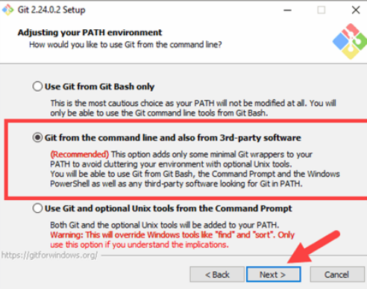

10. The installer now asks which SSH client you want Git to use. Git already comes with its own SSH client, so if you don't need a specific one, leave the default option and click **Next.**

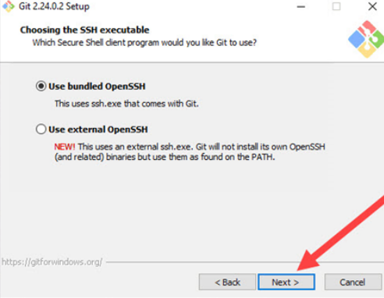

11.  Choose default server certificates for most users. If in an Active Directory environment, switch to Windows Store certificates. Click Next.

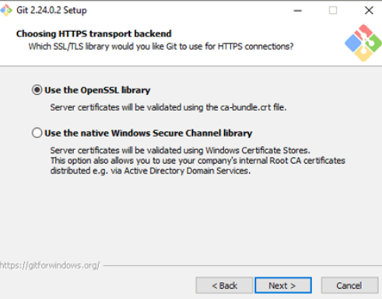

12. Stick with the recommended default for line ending conversion, as altering this may lead to formatting issues. Click Next.

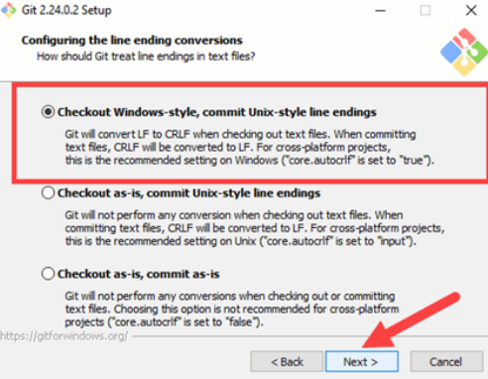

13. Choose the [terminal emulator](https://phoenixnap.com/glossary/terminal-emulation) you want to use. The default MinTTY is recommended, for its features. Click **Next**.

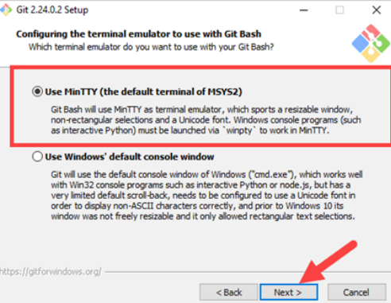

14. Stick to the default option for the git pull command unless you have a specific need to change its behavior. Click Next to proceed with the installation.

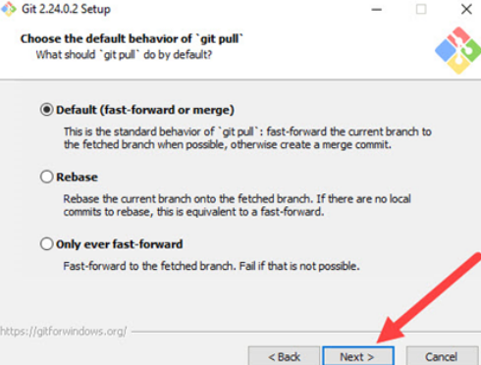

15. Select the default credential helper for stability. Click Next to proceed with the installation.

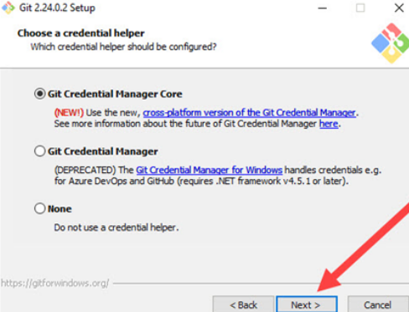

16. Default options are recommended, but here you can enable additional options. If you use symbolic links, tick the box. Click Next.

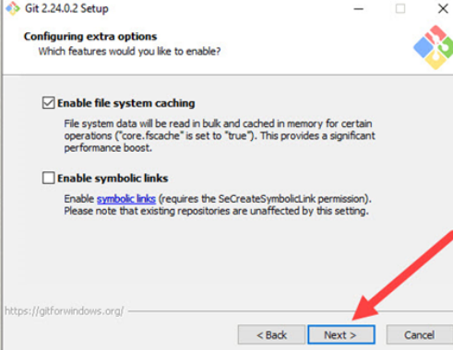

17. For the Git version, experimental features such as pseudo controls and a built-in file system monitor may be offered. Unless you're adventurous, leave them unchecked and click Install

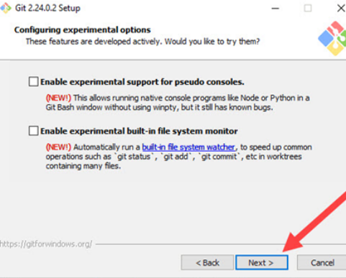

18. Once the installation is complete, tick the boxes to view the Release Notes or Launch Git Bash, then click **Finish**. 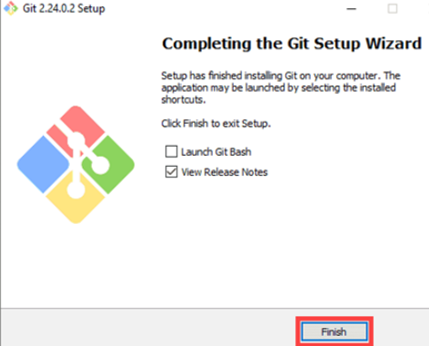

**Creating Repository on GitHub.**

1. After successful login into your account. Click on the option (+) to add new repository to your account.

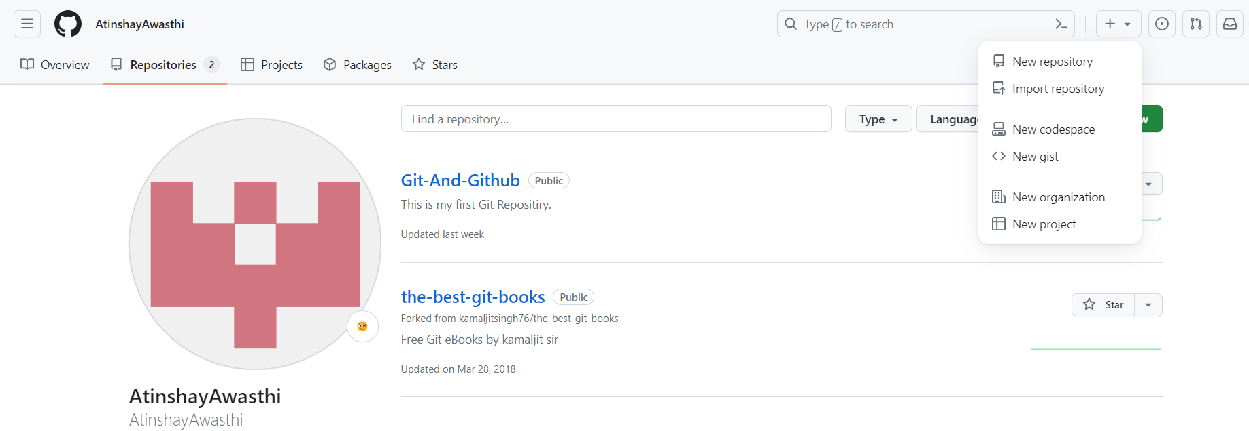

1. After clicking new repository option, we will have to initialize some things like, naming our project, choosing the visibility etc. After performing these steps click Create Repository button.

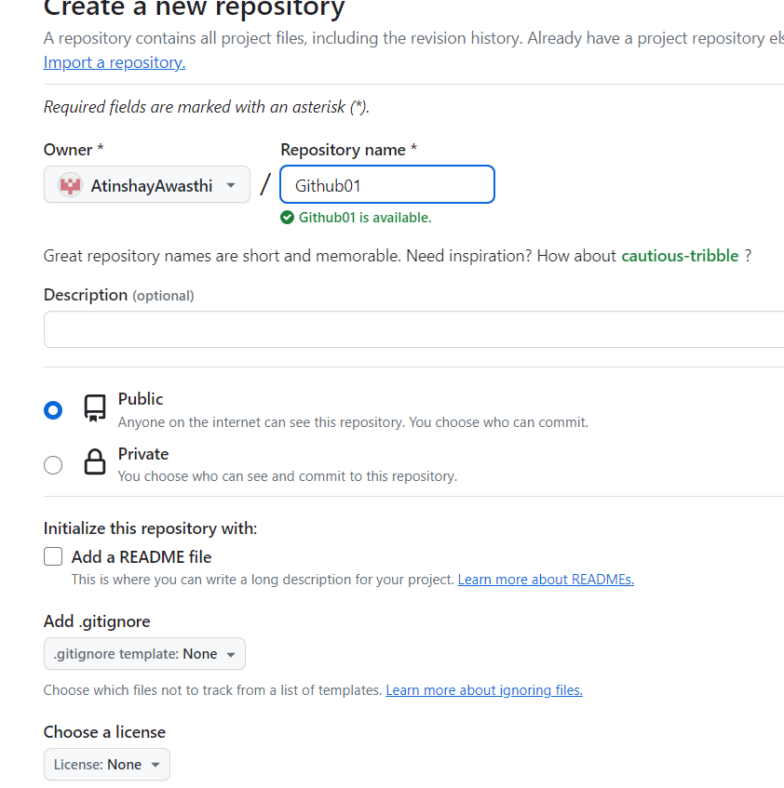

1. After clicking the button, we will be directed to below page. Right now the only file we have is a readme file.

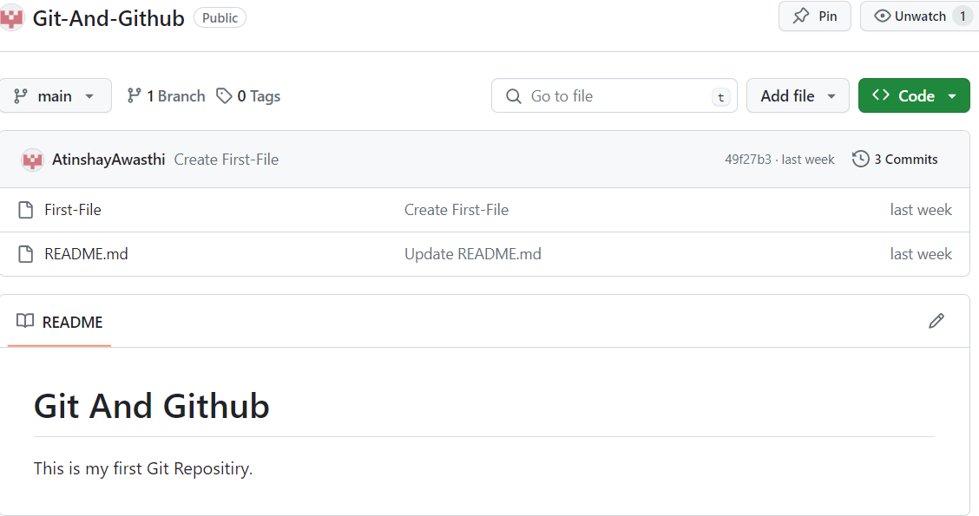

1. Now click on the “Upload files” button. Do some needed steps. Now we can see all the files in our Git Hub.

**How to Launch Git in Windows**

Git has two modes of use – a **bash scripting shell** (or command line) and a **graphical user interface** (GUI).

**Launch Git Bash Shell**

To launch **Git Bash** open the **Windows Start** menu, type ***git bash*** and press **Enter** (or click the application icon).

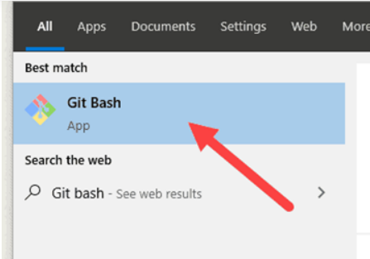

**Configure GitHub Credentials**

Configure your local Git installation to use your GitHub credentials by entering the following:

git config --global user.name "Atinshay"

git config --global user.email "aatinshay@gmail.com"

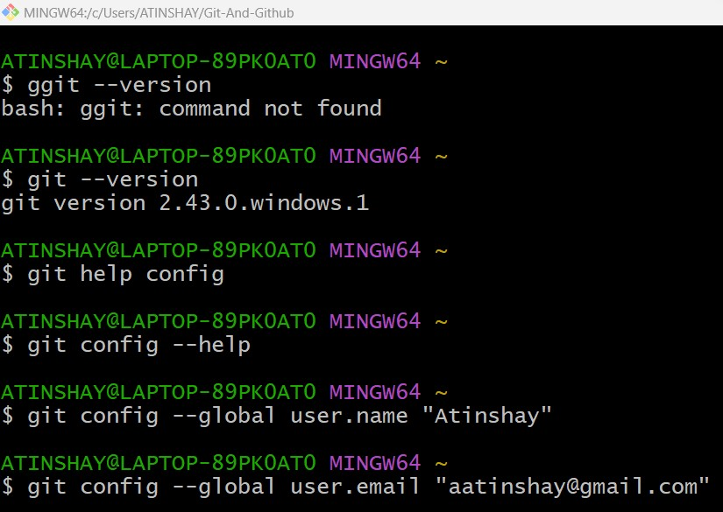

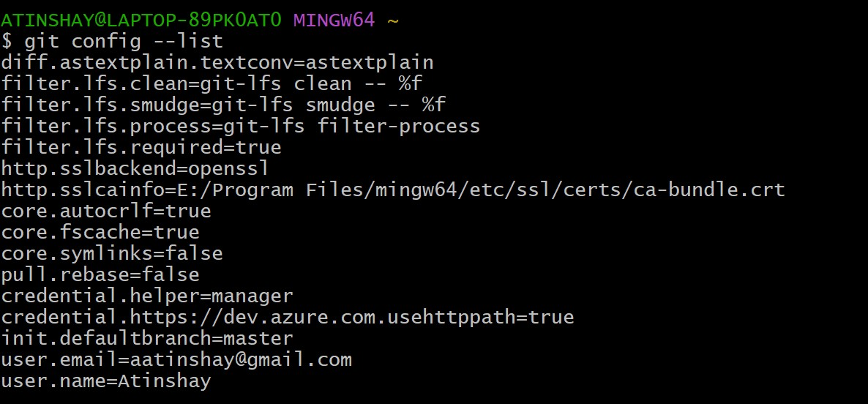

**Clone a GitHub Repository**

Go to your repository on GitHub. In the top right above the list of files, open the **Clone or download** drop-down menu. Copy the **URL for cloning over HTTPS**.

And put it in git bash command:

git clone https://github.com/AtinshayAwasthi/Git-And-Github.git

**List Remote Repositories**

Your working directory should now have a copy of the repository from GitHub. It should contain a directory with the name of the project. Change to the directory:

cd Git-And-Github

If it’s not working, you can list the contents of the current directory with the **ls** **command**. This is helpful if you don’t know the exact name or need to check your spelling.

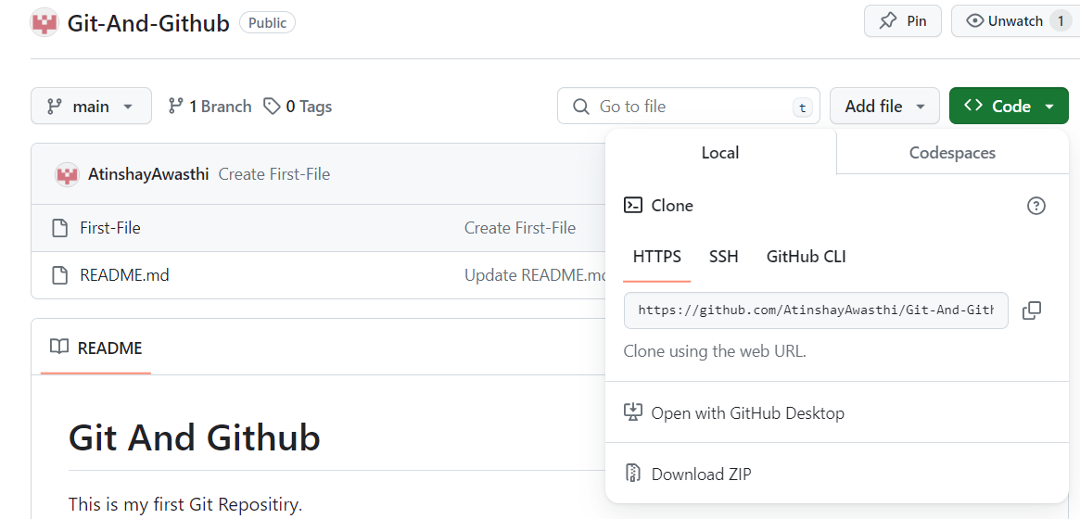

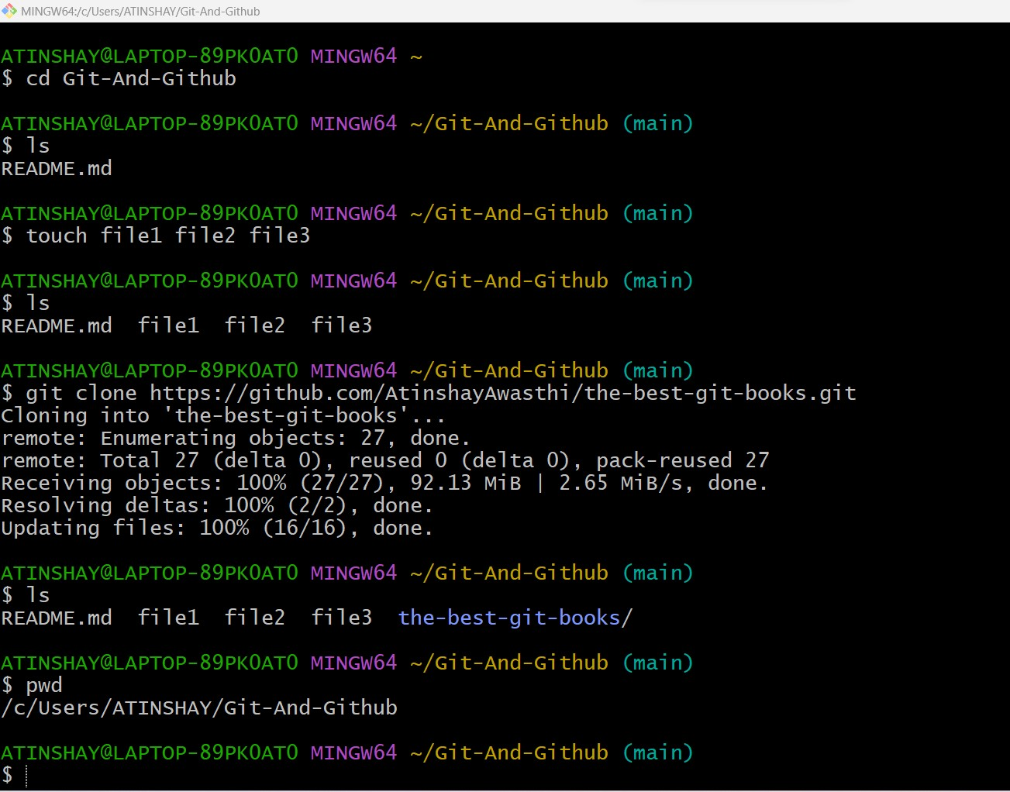

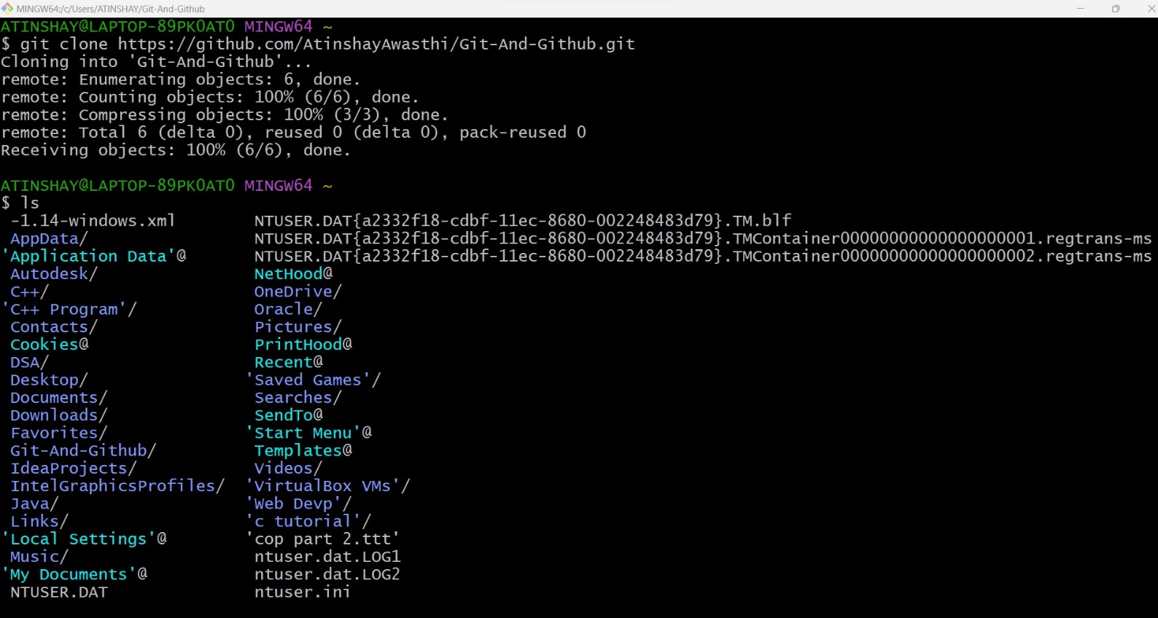

**7. Result/Output/Writing Summary:**

We have successfully install Git , and also created Github Account and created a repository and applied some commands on that.

**Learning outcomes (What I have learnt):**

**1.** I have learnt about Git and Github.

**2.** I have learnt about some git commands.

**3.** I have learnt about Repositories.

**4.** I have learnt about Fork , push and pull requests.

**5.**

**Evaluation Grid (To be created as per the SOP and Assessment guidelines by the faculty):**

|  |  |  |  |
| --- | --- | --- | --- |
| Sr. No. | Parameters | Marks Obtained | Maximum Marks |
| 1. |  |  |  |
| 2. |  |  |  |
| 3. |  |  |  |
|  |  |  |  |